
Fresher's Guide 2008
UNIVERSITY COMPUTER CLUB

Events in 2008
UCC Fresher's Welcome
Friday the 14th of March
7.00 PM – 11.00 PM
Cameron Hall Loft (above the UCC)
The fresher's welcome is to welcome you, as a new member, into the club. There will be a number of older members there to chat with. This is a great event to get to know some people and put faces to names. First time members get FREE pizza!

UCC Annual General Meeting
Tuesday the 25th of March
1.00 PM (common lunch hour)
Guild Council Meeting Room
The AGM is the meeting at which the new UCC committee will be elected for 2008. The only way to be represented is to attend. As a fresher, you should attend in order to run for the position as Fresher Representative. If you don't know where the Guild Council Meeting Room is, arrive in the UCC a little early and follow the mass exodus.

April Fool's Lan
Saturday the 31st of March
3.00 PM – some time Sunday
Cameron Hall Loft
The name explains it all. The UCC runs a LAN once every two months or so. These are your best chance to play against other UCCans at the LAN games of your choice. LANs are FREE for members, but friends are most welcome.

Zone3 9to1
Saturday the 23rd of June
9.00 PM – 1 AM
Zone3 Northbridge
Blast away that exam stress with the post-exams 9to1 at Zone3. Everyone loves laser combat, and everyone also loves laser combat after not having had any sleep and only just having finished a 3 hour long Physics exam. Come join us, but be warned; some of our players are quite experienced.

The UCC's 34th Anniversary Dinner
Friday the 5th of September
The UCC has a birthday. This year, the UCC turns 34 (0x22). Dinner has been held at a number of venues over the years, but is always priced for students. Last year, we celebrated 34 years at the Royal Perth Yacht Club. Come help us celebrate 34!

Cameron Hall Charity Vigil
Semester 2 – date to be confirmed
Once a year all of the clubs in Cameron Hall get together and hold a night of fun to raise money for charity. There is a cover charge, but you do get fed.
More details later in the year.

Pizza and Beer Nights
Last day of exams – Friday the 22nd of November
Exams are over. We will apply alcoholic beverages and bread-based fast foods to our stomachs in the refined grounds of the UWA Tav.
for more events, check out http://www.ucc.asn.au/infobase/events/

Table of Contents
Events in 2008 2
Start Here 3
Welcome from the Fresher Rep 4
About the University Computer Club 4
Getting Involved 4
Setting Up Your Account 4
Events 5
Projects 5
The UCC Committee 5
TLAs – Three Letter Acronyms 6
UCC Groups 7
UCC Machines 8
Common UNIX Commands 9
Using the Clubroom 10
Computing Facilities 10
Reading or Redirecting Your UCC E-mail 10
Changing Your UCC Password 10
Tools and Hardware 10
Books 11
Getting Help 11
Dispense 11
Maintaining Your Coke Account 11
Using Dispense from a Console 11
Using Dispense from the Snack Machine 11
UCC Online 12
Mailing Lists 12
IRC 12
Sponsors 13
Acknowledgements and Colophon 13
Glossary 14

Start Here
If you have a short attention span, here's what to do if you're new at UCC:
- Get an account (see page 4).
- Put some money in your dispense account (see page 11).
- Dispense a Coke (see page 11).
- Log in to the UCC servers from the clubroom or home (see page 10).
- Join the IRC server (see page 12) and say hello.
- Read the rest of this guide!

Welcome from the Fresher Rep
The UCC can initially seem like a pretty scary place for first time members. The location of the clubroom makes it feel as though you shouldn't be in the building, and often the members seem more concerned with their screen than the world around them. Stick around and you will quickly realise that this is not the case. I thoroughly recommend showing up to the Fresher Welcoming Evening (Friday 14th March) to get to know other club members and see that we aren't a scary bunch after all.

This guide will act as a nice first point of reference for the club's many benefits. Have a read through it and, if in doubt, ask any of the members and they should be more than happy to help you. In addition, there will be a Fresher Representative elected at our AGM who can bring your concerns to the committee of the club. The job is simple enough and it will help introduce you to the committee of the club and make the whole place seem less alienating.

Finally, welcome to the club.
Conrad Pogson
Fresher Rep, 2007

About the University Computer Club
The University Computer Club (or UCC for short) is a very unique group indeed. This is the UCC's 34rd year, making it older than clubs like the Homebrew Computer Club of Bill Gates and Steve Wozniak fame. The UCC has had its share of (in)famous hackers, with members who have gone on to work at IBM, Apple, Google, Microsoft and Berkeley. Members of the UCC have also been involved in numerous high profile open source projects, including GNOME, Mozilla, G++ (the GNU C++ compiler), FreeBSD and the Linux kernel.
For these reasons, new members may find the UCC to be a little intimidating at first. There are a lot of strange people (they're not all weird), sitting at a lot of strange computers (they're not all PCs), running even stranger software (it's not all Windows), but stick around and get involved. UCC caters for everyone, from hardcore operating systems geeks, to people who like to do scary things with hardware, to budding electronics nuts, robotics gurus, elite gamers and even people who just want a chair and a computer on which to read their email.
The UCC runs a variety of hardware and different computer architectures, including x86[-64], PowerPC, Alpha and SPARC, running operating systems like Tru64, Mac OS X, half a dozen flavours of Linux, BSD, Solaris and, of course, Windows. Unfortunately, we don't currently have anything running NeXTStep or VMS.

Getting Involved
So you've joined the UCC and you want to get involved? It's easier than you might think. Just turn up to the club room (see the map) and hang around. Some things you might like to know about getting involved with the club are detailed below.

Setting Up Your Account
One of the reasons for joining the UCC is to get a machine account. Machine accounts give you access to all of the UCC machines (with a few exceptions), as well as email, a web presence and many other benefits.
To set up your UCC account, you will need to go to the UCC clubroom (see the map on the back of this guide) and find a Wheel or Committee member. If you go up to the clubroom on O'Day there will probably be a Wheel member waiting for you. Otherwise, you'll have to shout out asking for help from a Wheel or Committee member.
Once you have secured your Wheel/Committee member, you'll need to show them your UCC membership card (which you got when you joined). You will also need to think of a user name for your account. Your user name will be used to log onto UCC machines, as well as for your email address and web page. For example, the user murphy will have the email address murphy@ucc.asn.au and the website http://murphy.ucc.asn.au/.

Events
The UCC runs an incredible number of events throughout the year, significantly more than many of the other clubs on campus. You can see a good selection of events planned for 2008 on the inside cover of this guide. Not all of our events are computer-ish in nature. However, a significant portion of them are (we are a computer club after all). Events include LAN gaming nights, the birthday dinner and of course the Fresher's Welcome. We have also run the occasional programming competitions. UCC members also throw a number of informal parties throughout the year, which members are free to attend.
Events, both formal and informal, are announced on one of the mailing lists and the website. There are two mailing lists commonly used for events: ucc-announce and ucc. There is more on the UCC's mailing lists near the back of this guide.

Projects
Projects are what make the UCC cool. At any one time, pretty much everyone in the UCC is working on something, usually at the detriment of their studies. The sum of the UCC's membership covers pretty much everything you want to know on topics like electronics, computer programming, physics, astronomy, web design, robotics, civil engineering and even things like medicine, music and fine arts. You may have to ask on the ucc mailing list to find some of these people, but they are usually very willing to help.
Some projects completed recently include:
- Upgrading the snack machine to accept student cards.
- An OpenID provider service for UCC members.
- Gaining acknowledgement from Wikipedia founder Jimbo Wales. ^{[citation needed]}
- UWA Pirate Handbook – an ongoing project to document what UWA units are really like.

If you have a project of your own, mention it to some people. Ask around for help in the clubroom and on the mailing list. You might find some help... if you ask politely.

The UCC Committee
Like most clubs, the day to day running of the UCC is handled by a committee. The committee spends the club's money, ensures we're well stocked with Coke and snacks, and organises events. In order to keep the day to day running of the club smooth, the UCC delegates certain functions to other groups, such as Wheel, Coke, and Door (see below).
Any member is permitted to attend a committee meeting, unless the President has declared the meeting is closed to general members. If you would like to receive reminders of the meetings, as well as the upcoming agenda, subscribe to the committee mailing list. For historical reasons, minutes are posted to ucc, so you probably want to subscribe to that too.
The UCC committee consists of 8 club members:
President  president@ucc.asn.au | The President is the figurehead of the club and the club's primary liaison with the Guild. He or she is also responsible for coordinating the committee and chairing the meetings.
Vice President  vp@ucc.asn.au | The Vice President assists the President in his or her duties, filling in and helping out where necessary.
Secretary  secretary@ucc.asn.au | The Secretary is responsible for dealing with correspondence in and out of the club. It is also his or her job to take minutes at committee meetings, and ensure they are posted to the mailing list and on the web.
Treasurer  treasurer@ucc.asn.au | Possibly the hardest job on committee, the Treasurer handles the club's finances. This involves regular banking, clearing out the cashbox and preparing biannual budgets for the Guild.
Ordinary Committee Members (x3)  ocm@ucc.asn.au | The three OCMs assist the committee as needed. OCMs carry out tasks like organising events, restocking supplies in the vending machine and helping to produce club publications.
First Year Representative  fresher@ucc.asn.au | The Fresher Rep is a position with a long tradition of broken promises. Every year, the Fresher Rep promises to turn up to committee meetings and fails to deliver. The job of the fresher rep is similar to that of an OCM, however they also act as the liason between the freshers and the rest of the club.

The President, Vice President, Secretary and Treasurer form the Club Executive and thus are ultimately responsible for the actions of the club. This means they are the sole signatories of the UCC bank account and are liable for the actions of the club as a whole.
As members of the UCC, you are eligible to run for any position on committee you wish. Elections are held at our Annual General Meeting and nominations are had at the meeting itself. We generally consider First Year Representative to be the best position for people new to the function of the UCC committee. However in the past, freshers have been known to fill other roles, notably that of an OCM.
You do not have to be nominated for the position of Fresher Rep. All Freshers who turn up to the AGM are automatically nominated for the position (unless, of course, you win another position). The non-fresher members then elect the Fresher Rep (yes, it's a little backwards).

TLAs – Three Letter Acronyms
Most UCC members have a TLA to identify themselves. You don't have to choose one immediately; however they are commonly used at committee meetings and to refer to people in shorthand. Your TLA can be anything, as long as it's unique. Originally it was limited to only letters; however now people use letters, numbers and symbols easily available on the keyboard.
The history behind the UCC using TLAs is that they were used to log in on operating systems that used RAD40 (Radix 40) for encoding usernames. A list of known members TLAs is available online.

UCC Groups
The UCC committee delegates specific duties and responsibilities to other people in the club. These groups, traditionally modelled after UNIX groups, are referred to often. It pays to be aware of what the responsibilities of each group are.
Wheel  wheel@ucc.asn.au | Wheel is in charge of maintaining the club's machines. They are the best people to see if you're having problems with the computers. Wheel maintains its own membership, but works hand in hand with Committee on issues relating to account policy. If you abuse your account, it will be locked by a Wheel member. The unlocking of accounts is at the discretion of Committee. Wheel have infrequent meetings, where they sing the secret wheel song.
Coke  coke@ucc.asn.au  (appointed by committee) | The Coke group are the people to talk to if you want to add money to your dispense account (see the section on dispense). They can also credit your account for bad dispenses and other tasks related to dispense.
Door  door@ucc.asn.au  (appointed by committeee) | The Door group is responsible for the clubroom itself. Only a member of door group can unlock the clubroom and keep it open for members during the day. This means that if the only Door group member in the room has to leave, then everyone will have to leave until another Door group member arrives.
Webmasters  webmasters@ucc.asn.au | The Webmasters are charged with maintaining the UCC web presence. Becoming a Webmaster usually involves showing some interest in the UCC website, as well as approval from an existing Webmaster or member of Wheel.
Winadmins  winadmins@ucc.asn.au  (appointed by committee) | In response to the decreasing availability of Wheel members during the day, the Winadmins group was created to give trusted members administrator access to the Windows desktop machines in the clubroom.

There should be big posters with pictures of all the people in most of these groups somewhere in the clubroom. Alternatively, shouting out 'is there anyone here in group?' will usually get you an answer. You can also see who's in each group online.
Unlike committee, obtaining membership to one of the UCC groups does not involve being elected. Membership of these groups entails a certain amount of trust, so you may not be allowed to join them straight away.
The exact entry requirements are often vague and it is generally accepted that you will nominate yourself once you feel you meet those requirements. Members join Wheel by invite only, and will be asked to attend a Wheel Meeting, where they too will be taught the Secret Wheel Song.
Do not despair if you're not made a Wheel member immediately. Sticking around and showing an interest through contribution is more important than just having the skills.

UCC Machines
In the clubroom...
User Servers | martello (Debian)  manbo (Solaris)  morwong (Tru64)  musundo (OpenSolaris)  mussel (Xen/Debian)
Oligoboots | combtail  (Windows 2000/Ubuntu)  colmata  (Windows XP/Ubuntu)
Apple Macintosh | arctic (Mac OS X)  apollo (Mac OS X)
Diskless Clients | velvet (Debian)  pitch (Debian)
Printers | phosphorus  (HP 1320)

Outside the clubroom...
Linux | cobbler (Debian)  cybium (Debian)
Terminal Servers | chimera
Services...
Dispense | mermaid
DNS | mooneye (Debian)
Files | manbo  martello
Flame | mooneye
Login | manbo  martello
Mail | mooneye
Routing | madako (Debian)
Switching | lorenzo  curviceps  olive
Wireless LAN | flying (Debian)  clearwing (OpenWRT)
Music | maroon (Debian)
Web (HTTP) | mermaid  mooneye
Webcams | flying  nautilus (MacOS 9)  novorossiisk (MacOS 7)
Xen Host | mermaid

Each user has two different home directories, a secure home directory hosted on martello and an insecure home directory hosted on manbo. Secure machines mount the insecure home directories as /away. Some machines can not be logged into by non-Wheel members.
Uses secure home directory | Uses insecure home directory | Not for general access
manbo | arctic | clearwing
martello | cobbler | flying
mussel | colmata | madako
morwong | combtail | mooneye
 | cybium | nautilus
 | sacheto | novorossiisk
 | pitch | mermaid
 | velvet
You can find out more about our machines, including exciting bits of history, on the web.

Common UNIX Commands
A large number of the UCC's computers run some form of UNIX. If you're never encountered UNIX before, it might be a bit daunting for you. While many UNIX operating systems come with nice graphical desktops, the power is all in the text-based shell. Here are some common shell commands, in no particular order.
Command | Description
logout  (you can also use Ctrl-D) | Logs you off the system (or closes the shell). Do this before you leave.
ls <directory name> | Lists the files in the given directory (like dir on DOS).
cd <directory name> | Change to the given directory.
mkdir <directory name>  rmdir <directory name> | Add/remove the specified directory (like md/rd on DOS).
pwd | “Print Working Directory”. Displays the path of the directory you are currently in.
more <file name>  less <file name> | Read through a file (space scrolls on a page, q will quit).
cp <source file> <destination> | Make a copy of a file in a new place.
mv <source file> <destination> | Moves a file to a new place (also used for renaming files).
rm <file name> | Deletes (removes) a file permanently.
alpine  elm  mutt | Three different programs to use for reading your mail. alpine is often easiest for first time users, although lacks some features.
nano <file name>  vim <file name>  emacs <file name> | Three different editors to edit text files. vim and emacs are somewhat more complex to use than nano, but much more powerful.
finger  who  w | Check to see who else is on a machine, how long they've been idle for and where they are connected from.
w3m <url>  lynx <url> | Two text based web browsers. They can take a bit of skill to drive. In w3m, press Ins to bring up a menu.
ssh <host name>  ssh <hostname> -l <username> | Log in (securely) to another (UNIX) machine. Specify a different username if required (eg, for tartarus).
ping <host name> | Ping another machine to see if it is up and what the latency between you and the target is. Press Ctrl-C to cancel.
man <command name> | Displays the manual for a command. Manuals offer lots of information about the command you are interested in. See man man for more information.
top | Displays an updating list of current processes on the system.
ps  ps aux (Linux)  ps -ef (other UNIX) | List the processes you are running on this terminal (names and ids). ps aux and ps -ef display all running processes on the system.
kill <process id number> | Stop a process. kill -9 will forcibly kill a process.
passwd | Change your login password.
Many commands have an available help summary that you can get by typing <command name> --help (eg ls --help) or by reading the manpage (see man above).

Using the Clubroom
The UCC clubroom is located on the 2nd floor of Cameron Hall (right above the Guild Tavern, see the back cover for a map). The UCC is usually open from about 9am (after the first door member arrives from 8am lectures) until 11pm (when UWA Security kick us out). It is also open on weekends from about noon 'til 11pm.
You can see if the clubroom is open via the Internet by using the webcams or using Jabber/Google Talk.

Computing Facilities
You are welcome to use pretty much every machine you can see in the clubroom (unless it belongs to someone else). Most machines require your user name and password to log in (see Setting up your Account if you haven't already done so). There are also a number of servers in the machine room which you can log into via SSH (look for PuTTY on a Windows computer), including mussel, martello and manbo. See UCC Machines in the middle of this guide.
Many of our machines run some flavour of UNIX (Linux, Solaris, NetBSD, IRIX, etc.) so it might take a bit of time to learn how to use them. To help you out, we have included our Common UNIX Commands in the middle of this guide.
Wireless access is available with the SSID ugg. If you're having trouble, try asking someone with a laptop (if they're not too busy).
All our computers have an unrestricted connection to the Internet, although clever traffic engineering means that some sites are much faster than others. You do not need to set up a UWA proxy while using UCC computers. We trust you not to abuse our connection.
You can connect to the UCC from outside by using SSH, which allows you to connect to other computers over the Internet. You'll need an SSH client: try PuTTY on Windows, or the Terminal on Mac OS. As a starting point, try connecting to ssh.ucc.asn.au, which should be accessible from anywhere in the world. Alternatively, if you're inside UWA or connected to one of our peering networks, you can connect directly to hostname.ucc.gu.uwa.edu.au. For more information on logging in to UCC machines, see our Network Login page on the website.

Reading or Redirecting Your UCC E-mail
Many people never read their UCC e-mail – however, if you intend to become a member of any groups, it's important that you either read it using a mail client (including our Webmail system), or forward it somewhere else (like a Gmail account). To forward your e-mail, create a .forward file in your home directory and enter your preferred e-mail address in it.

Changing Your UCC Password
To change your password from a Linux or UNIX machine, use the command passwd. To change your password from a Windows machine, press Ctrl-Alt-Delete and select Change Password.

Tools and Hardware

The UCC has a lot of tools for fixing (or destroying) things. We own a good soldering iron, a digital oscilloscope, a power drill, a jigsaw and numerous multimeters, as well as screwdrivers, various pliers, ratchets, crimping tools, saws, hammers, etc. All of these tools should be located in the big orange tool cupboard (unless someone is lazy) and should be returned there afterwards (even if someone was lazy). Tools can be borrowed, if they are written down in the theft book. We also have vast quantities of discrete components, random case hardware, semiconductors, integrated circuits, screws and cable. Members are free to use these.
This work is licensed under the Creative Commons Attribution-NonCommercial-ShareAlike License. To view a copy of this license, visit http://creativecommons.org/licenses/by-nc-sa/2.0/au/ or send a letter to Creative Commons, 559 Nathan Abbott Way, Stanford, California 94305, USA.
When using the UCC's tools, please do not use them to cut through live power cables or remove (and summarily lose) radioactive alpha emitters!

Books
The UCC has an incredibly large number of books. As well as lots of books we've picked up over the years for free, the UCC also has a number of expensive, definitive texts on a variety of technical subjects. Topics include electronics, operating systems design, GUI programming and computer science. The book collection is pretty much uncatalogued and unsorted, so you'll have to search for what you're looking for. Email books@ucc.asn.au to ask if we might have a title, or to say that you're borrowing it. UCC rarely purchases books, but if you think we really must own a certain title, mail the committee.

Getting Help
Sometimes you might get stuck trying to work out how to use a machine or something in the UCC. Don't be afraid to ask for help. Not everything people do in the UCC is easy to understand. Lots of the stuff designed for UCC is a bit complicated, and it might not be obvious how it works. Find someone who looks knowledgeable (and preferably not too busy) and perhaps ask them if they can help you out, or try the IRC channels (see below).

Dispense
Without a doubt, dispense is one of the most singularly important things in the UCC. It is a mish-mash of software and hardware and over the years has evolved from a simple way to electronically dispense drinks to your UCC electronic wallet. Much of the software was written by an eighteen-year-old! Services, printing, phone calls, drinks and snacks are all paid for with dispense. It even allows Door group to open the electronic door lock.

Maintaining Your Coke Account
The UCC drink and snack machines do not accept money directly. To get at their delicious contents you will first need some Coke credit. The usual method of doing this is to shout “Is anyone here in Coke?” in the clubroom. Assuming someone says “Yes!”, you can ask them to please add some money to your account. You will need to get a plastic bag from on top of the safe (under the windows), show them the bag with the money in it, and then put it in the slot in the top of the safe.

Using Dispense from a Console
The traditional way to use dispense is via a UNIX terminal on mussel or martello. Typing dispense at the prompt will bring up a list of purchases available to you. You will not be able to select items you do not have enough credit for. If you do not wish to select an item you can press q to return back to the prompt. You can also pay for phone calls and paper for the laser printer this way. You can then ask someone in Coke for your item, informing them you dispensed the item.

Using Dispense from the Snack Machine
The snack machine has also been connected to dispense. You can access dispense through the snack machine keypad. However, you need to set up your account for this: use the ucc-set-pin command from a UNIX prompt on mussel or martello to do this.
You can now type in your 5 digit user id, followed by your four digit PIN to authenticate to dispense. As well as the two digit codes for snacks in the machine, you can request a drink by selecting the slot number followed by an 8 (the machine will tell you what drinks are available if you wait for it to all scroll past; Coke is always 68). If you are in Door group, you can also use the machine to open the door.

UCC Online
The UCC currently has a number of websites and online services available for members. Some UCC websites include:
Homepage | http://www.ucc.asn.au/
Webmail | http://webmail.ucc.asn.au/
Mailing Lists | http://lists.ucc.gu.uwa.edu.au/mailman/listinfo
Planet UCC | http://planet.ucc.asn.au/
Webcams | http://webcam.ucc.asn.au/
Wiki | http://wiki.ucc.asn.au/

Mailing Lists
The UCC's mailing lists are the lifeblood of the club. Many of our members are not able to be around the clubroom due to work commitments, or because they are no longer in Perth. Yet still these members retain a partially active interest in the club through its mailing lists. The UCC hosts numerous mailing lists, for all manner of topics, browsable via the web interface listed above.
The UCC has a number of lists that you might be interested in:
- ucc-announce – the announcements list, you were asked if you wanted to be subscribed to this list when you signed up. If you said “no”, subscribe now.
- ucc – the general discussion list, most of the UCC's discussion takes place on this list, as well as announcements for informal events like parties and trips to the pub (when you're old enough). Most UCCans are subscribed to this list.
- committee – the open committee list, anyone interested in committee can sign up to this mailing list. The committee also has a private list for sensitive matters: committee-only.
- tech – the list for discussing the UCC's hardware and computers. General computer discussion should take place on the ucc list instead.

IRC
Without a doubt, the easiest way to waste time in or out of UCC is chatting on our Internet Relay Chat (IRC) server. It's also a great way to get help with problems you're having at UCC, with computers generally, or with Uni life.
The best way to get on our server is to SSH to UCC (see the Computer Facilities section) and then type irssi -c irc.ucc.asn.au. After you've connected, you can type “/join #ucc” to join the UCC channel.
Alternatively, you can try connecting from home with mIRC or XChat – connect to the server irc.ucc.asn.au and join the channel #ucc.
Beware – some denizens of IRC are a bit strange, and the UCC's server is no exception. Keep your sense of humour firmly engaged at all times.

Sponsors
Thanks to all the UWA departments who sent us computer gear to sort through for spares and even replacement servers (especially ITS and the School of Population Health), and a big thanks to the Guild for everything they provide for us.
Thanks to all the Perth businesses who kindly sent us their old kit. Their trash is our treasure: in particular, Fugro Seismic Imaging, XSI, and Computer Angels.
For more information on all of our sponsors, both this year and in previous years, check out the website: http://www.ucc.asn.au/sponsors/

Acknowledgements and Colophon
This guide is published each year thanks to the hard work of dedicated UCC members, including Luke Williams, Conrad Pogson, Rufus Garton-Smith, David Adam, James Cox, Anil Sharma, Scott Young and Davyd Madeley. This guide rests of the shoulders of giants, thanks to past work by Davyd Madeley, Bernard Blackham, Nick Rohrlach and many forgotten others.
Also thanks to everyone who manned the UCC's stall and clubroom on O'Day. Finally, thanks to the Committee and member of Wheel, who keep the club running, even when they really don't have time.

For more information, remember to check out the UCC's website at:
http://www.ucc.asn.au/

Glossary
(ACC) Murphy | aka. Dr ACC Murphy – A Computer Called Murphy. Dr ACC Murphy is infamous around the UCC. He even receives mail!
Alpha | A CPU architecture produced by DEC.
BSD | Berkeley Systems Distribution – a UNIX developed at Berkeley, now better known through the FreeBSD, NetBSD and OpenBSD UNIXes.
blog | aka. weblog – sort of like a journal on the Internet (you don't have one?). Syndicated by a Planet.
Bright link | A connection to the Internet supplied by the ISP arm of Western Power. It allows us to get a free connection to anywhere on the Internet.
Coke credit | If you gotta ask, you ain't got it! Coke credit is how people usually refer to money in your dispense account.
Coke Group | The people who can put money (Coke credit) in your dispense account.
Debian | a Linux distribution popular in the UCC due to its community nature.
DEC | Digital Equipment Corporation – made a lot of cool stuff, including the PDP and VAX computers and VMS. Bought out by Compaq, who were bought out by HP.
DEC Terminal | A dumb serial terminal, useful for plugging into the serial console on servers (possibly via a terminal server). Has a model number like vt100, vt200 or vt420.
dispense | dispense started off as a way to dispense Cokes from the online Coke machine, and has since grown into the way UCCans think the world should do business.
Door Group | the group of people charged with keep the room open, tidy and safe.
Firefox | A web browser by the Mozilla Foundation, arguably the second-worst Internet browser – the worst is every other browser.
Flame | Flame is the UCC's MUD; however unlike most MUDs, Flame is not a game, and is mostly used for chatting.
Fresher | A new university student, usually also a first time UCC member.
Fresher Rep | Fresher Committee member, usually chosen because they look like they'll make a good worker drone in the future. Represents the freshers at committee meetings, if they attend.
GNOME | GNU Networked Object Model Environment – an open source desktop environment aimed primarily at UNIX computers. Popular in the UCC.
GNU | GNU is Not Unix – a layer of libraries and utilities to implement a UNIX like operating system, commonly used on top of Linux.
IRIX | A UNIX used on machines made by SGI.
Internet Explorer | Just use Firefox. No, really.
kernel | The core of an operating system. All operating systems have a kernel, some popular ones include the Linux kernel and the Mach kernel.
LDAP | Lightweight Directory Access Protocol, used for authentication at the UCC.
Linux | the kernel (basis) of an open source UNIX operating system that has developed quite a following among computer scientists and engineers.
loft | the area above the UCC that looks down into the UCC clubroom. LAN gaming and other activities take place up there.
machine room | The UCC data centre. This is the small room with the glass doors that is located within the clubroom. All of our servers are kept in this room. It is locked when there is no one from Wheel around.
mailing list | a way of communicating with a very large number of people via email. The UCC has several mailing lists of varying popularity.
MIPS | Microprocessor without Interlocked Pipeline Stages – a computer architecture used extensively by SGI and in the Sony PS2.
Mozilla (Corporation) | develop several open source web related products, such as Firefox and Thunderbird.
OCM | Ordinary Committee Member – the worker drones of the UCC Committee, they do lots of work, for little reward.
Oligoboot | boots more then one operating system (selectable when you boot).
NeXTStep | An operating system developed by NeXT before they were bought out by Apple. Lots of NeXTStep is incorporated into Mac OS X.
open source | A software ideology, where the source code to software (what is compiled into the program you run) is freely available. Also known as Free Software, exactly what makes a program open source is a good way to get into an argument.
Planet | A web page that syndicates blogs. UCC has one at http://planet.ucc.asn.au/
Secret Wheel Song | The song that is supposedly sung at the beginning of each Wheel meeting.
SGI | Silicon Graphics Incorporated – used to make cool graphics workstations such as the Indy and Indigo2 machines.
SNAP | Student Network Access Project – the way to get unrestricted access to the Internet at UWA, charged to your tartarus account.
Solaris | A UNIX developed by Sun Microsystems.
tartarus | Also referred to as the UWA Student Server or Student Netusage account.
terminal server | Sort of a router for serial ports, allows you to connect to one serial port from another. Usually connected to DEC Terminals, servers and dispense. (It can also refer to other sorts of servers which provide login sessions over the network).
theft book | this is where you write down that you borrowed tools from UCC. It is not for borrowing books; you mail books@ucc.asn.au to do that.
TLA | Three Letter Acronym – a way to refer to UCC members, often used in the minutes of meetings.
Tru64 | A UNIX that is used on Alpha, now owned by HP.
Ubuntu | A Linux distribution derived from Debian. Funded with space money.
UCCan | someone who spends a lot of time in the UCC.
UniSFA | the University Science Fiction Association, the ones down the hall.
WAIX | WA Internet eXchange – a group of ISPs and interested bodies who peer resources on the Internet for mutual benefit.
Wheel Group | the group responsible for maintaining computers, accounts and services in UCC.
Ground Floor
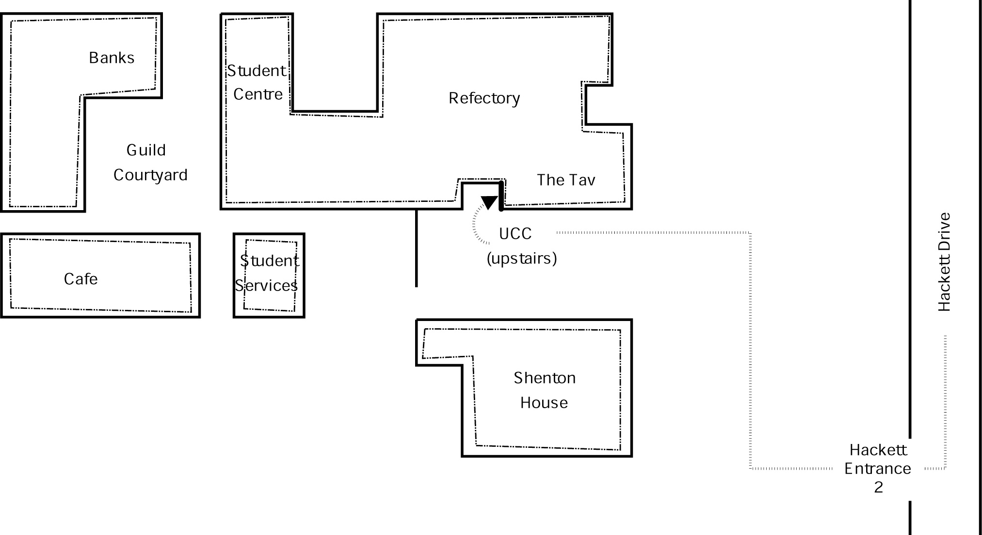
Second Floor
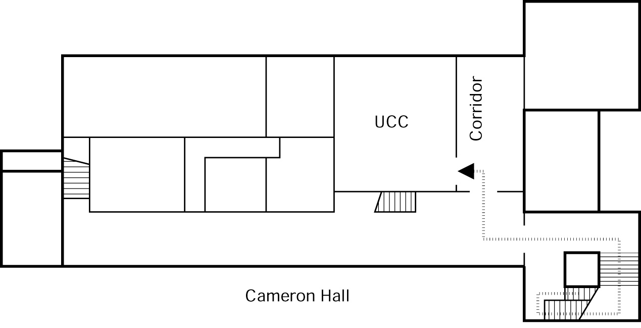
Drink Voucher  use this code in the UCC on O'Day for the drink of your choice | Contact Us
+61 8 6488 3901
Box 22, M300
Guild of Undergraduates
35 Stirling Hwy
Crawley, WA, 6009
committee@ucc.asn.au
http://ucc.asn.au/
2008 UCC Fresher's Guide
© 2005-2008, University Computer Club

Words in italics are defined in the Glossary.
UCC Mailing Lists can be found at http://lists.ucc.gu.uwa.edu.au/mailman/listinfo
http://www.ucc.asn.au/infobase/events/
http://www.ucc.gu.uwa.edu.au/member/tla.ucc
http://www.ucc.asn.au/infobase/groups/
http://www.ucc.asn.au/machines/
http://webcam.ucc.asn.au/
http://www.ucc.asn.au/services/door.ucc
http://ucc.asn.au/services/login.ucc
http://webmail.ucc.asn.au/

